**Lab Session#10**

Roll no: 20k-0409 Name: Mukand Krishna

**Task#1**

Design 2-bit comparator and Truth Table

|  |  |  |  |  |  |  |
| --- | --- | --- | --- | --- | --- | --- |
| **A1** | **A0** | **B1** | **B0** | **A>B** | **A<B** | **A=B** |
| 0 | 0 | 0 | 0 | 0 | 0 | 1 |
| 0 | 0 | 0 | 1 | 0 | 1 | 0 |
| 0 | 0 | 1 | 0 | 0 | 1 | 0 |
| 0 | 0 | 1 | 1 | 0 | 1 | 0 |
| 0 | 1 | 0 | 0 | 1 | 0 | 0 |
| 0 | 1 | 0 | 1 | 0 | 0 | 1 |
| 0 | 1 | 1 | 0 | 0 | 1 | 0 |
| 0 | 1 | 1 | 1 | 0 | 1 | 0 |
| 1 | 0 | 0 | 0 | 1 | 0 | 0 |
| 1 | 0 | 0 | 1 | 1 | 0 | 0 |
| 1 | 0 | 1 | 0 | 0 | 0 | 1 |
| 1 | 0 | 1 | 1 | 0 | 1 | 0 |
| 1 | 1 | 0 | 0 | 1 | 0 | 0 |
| 1 | 1 | 0 | 1 | 1 | 0 | 0 |
| 1 | 1 | 1 | 0 | 1 | 0 | 0 |
| 1 | 1 | 1 | 1 | 0 | 0 | 1 |

**Circuit Diagram**

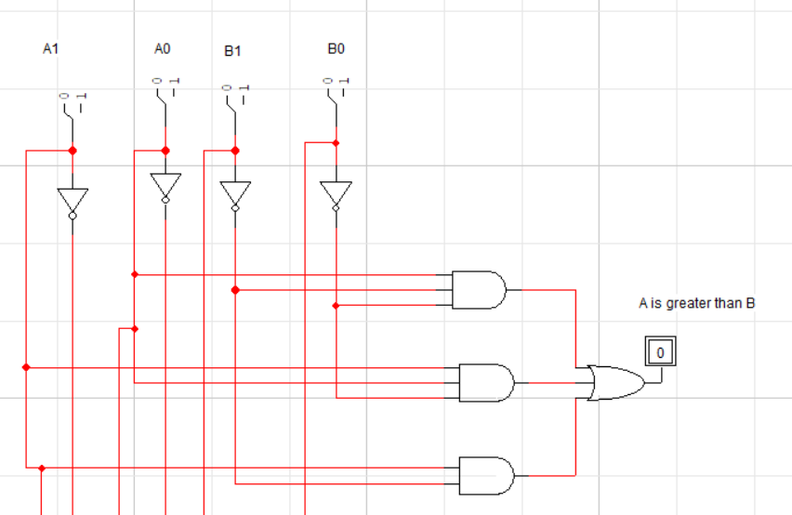

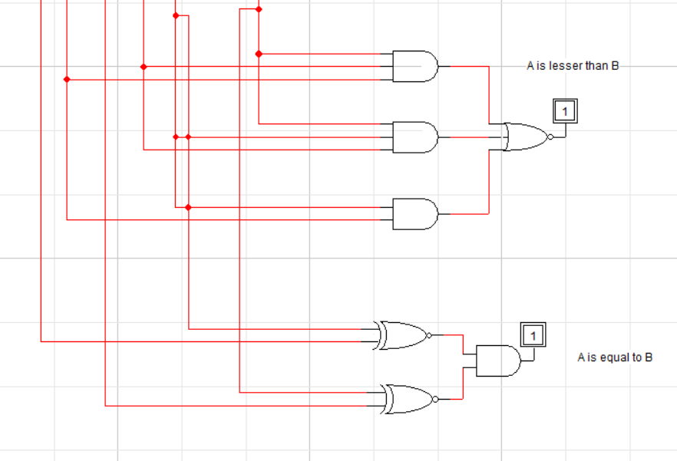

**Task#2**

Find minimal SOP and POS expressions for the outputs L, E, and G using K-map

**K-Map for output L (A<B)**

|  |  |  |  |  |
| --- | --- | --- | --- | --- |
|  | B1~B0~ | B1~B0 | B1B0 | B1B0~ |
| A1~A0~ | 0 | 1 | 1 | 1 |
| A1~A0 | 0 | 0 | 1 | 1 |
| A1A0 | 0 | 0 | 0 | 0 |
| A1A0~ | 0 | 0 | 1 | 0 |

**SOP**

**L:**  A < B = B1A1~ + B0B1A0~ + A1~A0~B0

**POS**

**L:** A < B **= (**B1+ B0) **+** (A1~+A0) + (A0~ + B1) + (A1~ + B1) + (A1~ + B1~ + B0)

**K-Map for output G (A > B)**

|  |  |  |  |  |
| --- | --- | --- | --- | --- |
|  | B1~B0~ | B1~B0 | B1B0 | B1B0~ |
| A1~A0~ | 0 | 0 | 0 | 0 |
| A1~A0 | 1 | 0 | 0 | 0 |
| A1A0 | 1 | 1 | 0 | 1 |
| A1A0~ | 1 | 1 | 0 | 0 |

**SOP**

**G:**  A > B = A1B1~ + A0B1~B0~ + A1A0B0~

**POS**

**G:**  A > B = (A1+A0) (A1+B0~) (A1+B1~) (B1~+B0~) (A0+B1~)

**K-Map for output E (A = B)**

|  |  |  |  |  |
| --- | --- | --- | --- | --- |
|  | B1~B0~ | B1~B0 | B1B0 | B1B0~ |
| A1~A0~ | 1 | 0 | 0 | 0 |
| A1~A0 | 0 | 1 | 0 | 0 |
| A1A0 | 0 | 0 | 1 | 0 |
| A1A0~ | 0 | 0 | 0 | 1 |

**SOP**

**E:**  A = B **=** A1~A0~B1~B0~ + A1~A0B1~B0~ + A1A0B1B0 + A1A0~B1B0~

A = B: (A0 **Ex-NOR** B0) (A1 **Ex-NOR** B1)

**POS**

**E:**  A = B = (A1~ + B1) + (A0~ + B1~ + B0) + (A0 + B0~) + (A1+ B1~)

---------------END---------------